Name:__________________________________ Per:____ Scores: #1:_____ #2:_____ #3:_____ #4:_____ #5:______
Spring Final Review for Unit 6 Sequences
Learning Target #1: “I can recognize that sequences are functions with limited domain.” F-IF-3
- What is a function?

- What is a sequence?

- List the differences between a sequence and a function in the four representations.
Situation | Equation | Table | Graph

- Is a sequence a function? Include the similarities and differences in your explanation.

Learning Target #2: “I can identify sequences as either arithmetic or geometric.”
- Determine if the given sequences are Arithmetic, Geometric, Neither, or Both. Explain how you know your choice is correct. Then determine the zeroth term and the next 3 terms.
c. 8, 4, 2, 1, …  Circle: Arithmetic, Geometric, Neither, Both  Explain how you know:  Zeroth Term: Next 3 Terms: | d. 5, 5, 5, 5, …  Circle: Arithmetic, Geometric, Neither, Both  Explain how you know:  Zeroth Term: Next 3 Terms:
c. 33, 34.25, 35.5, 36.75, …  Circle: Arithmetic, Geometric, Neither, Both  Explain how you know:  Zeroth Term: Next 3 Terms: | d. 12, -48, 192, -768, …  Circle: Arithmetic, Geometric, Neither, Both  Explain how you know:  Zeroth Term: Next 3 Terms:

Learning Target #3: “I can construct arithmetic sequences in the four representations: situation, table, graph, and equation, and use them to model situations.” F-LE-2, F-BF-2
- Create your own ARITHMETIC SEQUENCE and represent it in the four representations below.
Situation: Create an Arithmetic Sequence. | Explicit Equation: Write the Explicit Equation for your Arithmetic Sequence.
Table: Create the Table for your Arithmetic Sequence.  n 0 1 2 3 4 10 50 100  t(n) | Graph: Create the Graph for your Arithmetic Sequence.  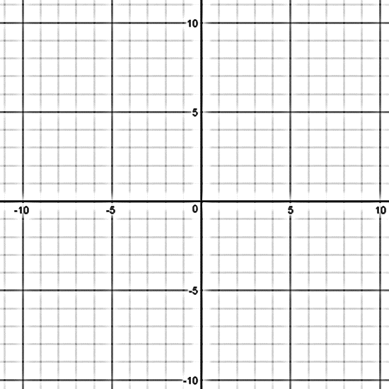

Learning Target #4: “I can construct geometric sequences in the four representations: situation, table, graph, and equation, and use them to model situations.” F-LE-2, F-BF-2
- Create your own GEOMETRIC SEQUENCE and represent it in the four representations below.
Situation: Create a Geometric Sequence. | Explicit Equation: Write the Explicit Equation for your Geometric Sequence.
Table: Create the Table for your Geometric Sequence.  n 0 1 2 3 4 10 50 100  t(n) | Graph: Create the Graph for your Geometric Sequence.
Learning Target #5: “I can write arithmetic and geometric sequences both explicitly and recursively.” F-BF-2
- Consider the following sequence 2, 4, … Assuming the sequence is ARITHMETIC answer the following:

i. Write the next four terms. | ii. What is the Common Difference? |  | iii. What is the zeroth term, $t\left(0\right)$?
iii. Write the explicit equation for $t\left(n\right)$. |  | iv. Write the recursive equation for $t\left(n+1\right)$.

- Consider the following sequence 2, 4, … Assuming the sequence is GEOMETRIC answer the following:

i. Write the next four terms. | ii. What is the Common Ratio? |  | iii. What is the zeroth term, $t\left(0\right)$?
iii. Write the explicit equation for $t\left(n\right)$. |  | iv. Write the recursive equation for $t\left(n+1\right)$.

- Go back to #6 where you created your own Arithmetic Sequence. Now write the recursive equation for that sequence. Don’t forget to write a term!

- Go back to #7 where you created your own Geometric Sequence. Now write the recursive equation for that sequence. Don’t forget to write a term.!

- In your own words, explain how to write a recursive equation.

