Name: ________________________________________ Period: ________ Date: ________
Unit 1 PRACTICE
- Write the equation of the line for the given points.

- Use the pattern to complete each Diamond problem.

- Evaluate the following problems when $x=-2$, $y=-3$, and $z=5$.

- Solve each equation for $x$. Check your solution.

- Describe a line with a …..
Positive slope |  | Zero slope
Negative slope |  | Undefined slope
- Graph these equations on the coordinate plane. Label them!
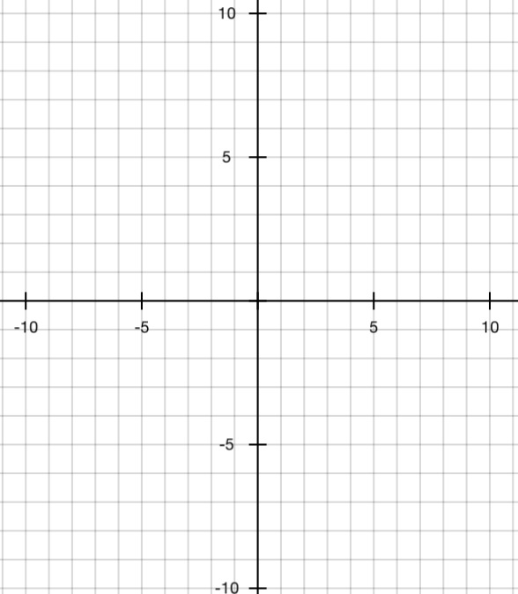
Line A $y=-\frac{2}{3}x+3$

Line B $y=2x+1$

Line C $y=-2x+9$

Line D $y=\frac{2}{5}x-4$

- Match graphs with their equations.

Graph 1 goes with … | Graph 2 goes with … | Graph 4 goes with …

- For the equations listed in #7, identify the slopes and $y$-intercepts.

