Name: ___________________________________________________ Period: __________ Team:___________
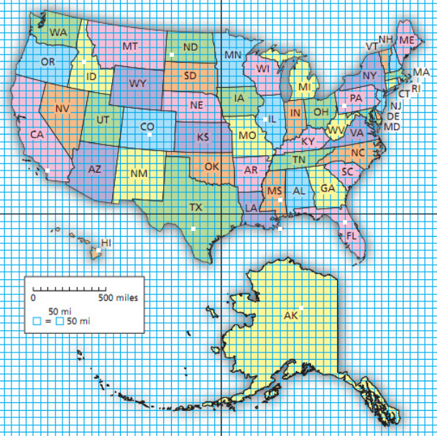
Treasure Hunt

Directions: There is a treasure hidden in one of the locations across the US. In order to find the location of the treasure you’ll have to graph the linear system of inequalities.

$$2x+3y<18$$
$$-4x-4y<8$$
$$-3x+4y<12$$
$$y>-4$$
$$x<6$$

The treasure is located at the coordinates which is in the state of

