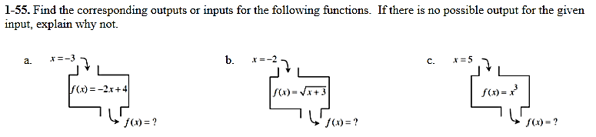

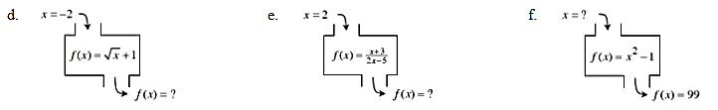

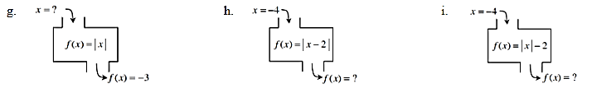

Learning Log:
- In a complete sentence, explain what a function machine is.

- Go back to your work yesterday and answer these questions.

  - Looking at the table, what is $f(3)$? $f(-1)$? $f\left(7\right)?$

  - Looking at the graph, what is $f(0)$? $f\left(-5\right)?$ $f\left(-9\right)$

