Name: _____________________________________ Formative Scores: #1:_____ #2:_____ #3:_____ #4:_____ #5: _____
Inequalities Individual Assessment Corrections Form
Learning Target #1: “I understand all of the symbols associated with inequalities and understand what a solution set represents.”
PROBLEM | CORRECTIONS
- Write a number that would be included in each solution set.
  - $x ≥ - 2$
  - $x < 1$
  - $-1 < x ≤ 4$

- When graphing a linear inequality in one-variable when do I use a solid boundary point? What does it mean in terms of my solution set?
- When graphing a linear inequality in two-variables, when do I use a dashed boundary line? What does it mean in terms of my solution set?

Learning Target #2: “I can create, solve, and graph inequalities in one variable.” A-CED.1, A-REI.3
PROBLEM | CORRECTIONS
- Solve the given inequality. Then graph the solution set.  $$2\left(x-5\right)≤8$$ | $$2\left(x-5\right)≤8$$
- Mrs. Davis wants to join a gym. The gym closest to her house is offering this New Year’s Resolution Deal: $20 a month with a $10 registeration fee. If she only has $250 saved up, what are the possible amount of months she can be a member of the gym? Write and solve an inequality that represents this situation. Write a sentence answer explaining what your solution set means. Graph the solution set with in context.

Learning Target #3: “I can create, solve, and graph inequalities in two variables.” A-REI.12
PROBLEM | CORRECTIONS
- Graph the following inequality:  $3y-12x>-6$ | 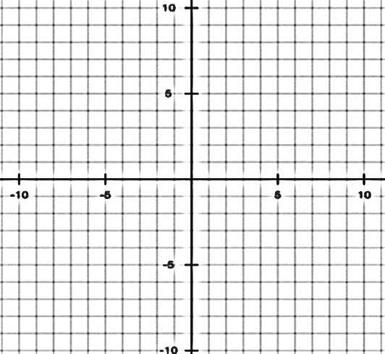
- Mr. and Mrs. Davis want to do different activities over summer break. Mrs. Davis wants to go to Disneyland and Mr. Davis wants to go to Giants games. After all expenses are thought of, a trip to Disneyland will cost the family $400 and a trip to the Giants stadium will cost the family $200. If the Davises have saved $6,000 for summer activities, what are their options for visiting these locations? Create an inequality that will represent this situation. Let $x$ = number of trips to Disneyland and let $y$ = the number of trips to the Giants games. Graph the solution set. Choose a solution that will make Mr. Davis happy and explain it. Choose a solution that will make Mrs. Davis happy and explain it. |  | 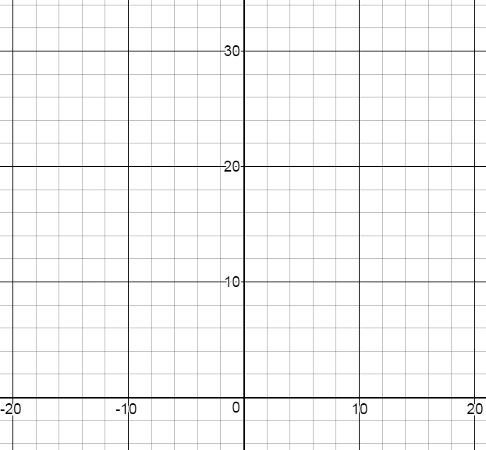
Learning Target #4: “I can graph the solution set to a system of linear inequalities in two variables.” A-REI.12
PROBLEM | CORRECTIONS
- Graph the system of inequalities. Make sure I can CLEARLY see your solution set.

$$y≤\frac{1}{2}x+2$$
$$y>-\frac{2}{3}x+1$$

Learning Target #5: “I can interpret solutions as viable (practical, realistic, usable) or nonviable (not practical, realistic, usable) within context.” A-CED.3
PROBLEM | CORRECTIONS
- Look back at #5. Give a viable solution within the solution set and explain what it means.
- Look back at #5. Give a nonviable solution within the context and explain why it is not realistic.
- Look back at #7. Give a viable solution within the solution set and explain what it means.
- Look back at #7. Give a nonviable solution within the context and explain why it is not realistic.

Which learning targets do you need to continue practicing during your deliberate practice time?

What problems will your work on?

What worked for you, in terms of being successful with these learning targets?

What did not work for you, in terms of being successful with these learning targets?

What will you do to ensure that you understand and can apply the next learning targets?

