Name:____________________________________________________________________________ Period:_________
Study Guide for Unit 5 Exponential Functions
Learning Target #1: “I can apply the rules of exponents.” N-RN.1, N-RN.2
Simplify the exponential expressions. Remember to FULLY simplify, so no negative exponents in your final answer.
- $4a^{3}∙2bc∙ab^{2}c^{5}$ | - $\frac{24ab^{8}}{8b^{6}}$ | - ${\left(13x^{2}\right)}^{0}∙2x^{3}x^{7}$ | - ${\left(\frac{c^{2}}{c^{5}}\right)}^{-2}$
- ${\left(\frac{{2x}^{3}}{8xy^{8}}\right)}^{0}$ | - $8^{4/3}$ | - $\frac{15h^{3}}{5h^{6}}$ | - ${\left(\frac{x^{8}}{x^{2}}\right)}^{3}$
- ${\left(m^{3}m^{4}\right)}^{2}$ | - $\left(3xy^{4}\right)\left(3x^{2}y\right)$ | - ${49}^{1/2}$ | - ${\left(3x^{3}y^{2}\right)}^{-3}$

Learning Target #2: “I can create and graph exponential functions and use them to solve problems.” A-CED.1, A-CED.2, N-Q.2,N-Q.3, F.BF.1
- Write the exponential equation for the graph that passes through $\left(3, 128\right)$ and $\left(0, 2\right)$.

- Write the exponential equation for the graph that passes through $\left(0, 7\right)$ and $\left(3, 56\right)$.

- Graph the equations you found in #13 and #14.

Equation: Equation:
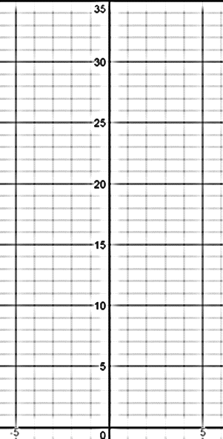

Learning Target #3: “I can investigate the family of exponential functions through the four different representations, graph, table, equation, and situation, and I can interpret the key features/parameters.” F-IF.4, F-IF.7e, F-LE.2, F-LE.5
- The M&M Lab activity used the equation $y=200{\left(\frac{1}{2}\right)}^{x}$, where $y =$ the total number of M&Ms and $x =$ number of trials. Using that equation, how many M&Ms would be left after 3 rounds? After 5 rounds?

Learning Target #4: “I can identify exponential functions as representing growth or decay.” I-IF.8b, F-LE.1c, F-IF.6
- Create a situation that would be modeled by decay. Write the equation for that situation.

- Create a situation that would be modeled by growth. Write the equation for that situation.

- What do you know about the multiplied for a decay model?

- What do you know about the multiplied for a growth model?

