Name:____________________________________________________________________________ Period:_________
Study Guide for Unit 2, Unit 3 and Unit 4
Unit 2 (Chapter 3) Solving Equations
- Solve for $x$. Check your solution.
- $\left|5-x\right|=9$ | - $6\left(x+2\right)=3\left(5x+1\right)$ | - $\left|2x+3\right|=-7$
- $\left(x-1\right)\left(x+7\right)=\left(x+1\right)\left(x-3\right)$ | - $\left|4x+1\right|=10$ | - $2x-5\left(x+4\right)=-2\left(x+3\right)$
- $4x-2\left(6-x\right)=6$ | - $x\left(2x-4\right)=\left(2x+1\right)\left(x+5\right)$ | - $\left|2x-3\right|=7$

Unit 3 (Chapter 4) Linear Systems
- Explain what the solution to a system of equations is.

- What are the 4methods we used to solve linear systems?

- Practice using each method by deciding which method is best used for these problems.
- $4x+y=2$  $$-3x-y=-1$$ | - $2x-4y=10$  $$x=2y+7$$
- $y=-2x+9$  $$y=\frac{1}{2}x+4$$  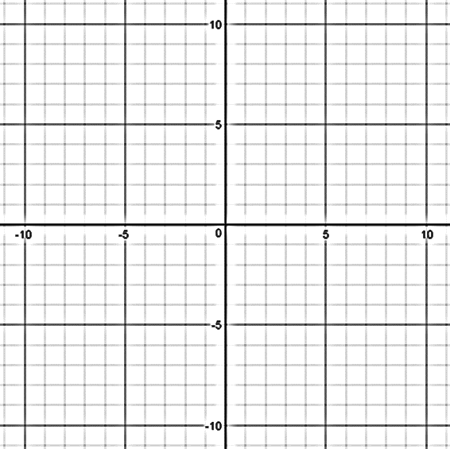 | - $x=y+3$  $$x=3y+5$$

- I want to get gym membership but I am not sure which one to get. There are 2 gyms close to our house. Planet Fitness and Anytime Fitness. Planet Fitness is doing a Memorial Day sale of $10 a month and $100 initial payment which they will donate to a charity of your choice. Anytime Fitness is not running a sale right now. Their plan is $60 a month but with no initial fee. When will these memberships be the same price?

- Write the two equations that represent the total cost for a gym membership at Planet Fitness and at Anytime Fitness. Write let statements to define what $x$ and$y$ stand for.
Let $x =$ | Let $y =$
Planet Fitness: | Anytime Fitness:

- Solve using the graphing method and one algebraic method. Did you get the same answer? At how many months? What is the cost?

- If I only want to go to the gym for the first 4 months, which gym membership should I get? Why?

Unit 4 (Chapter 9 section 2) Linear Inequalities
- When graphing inequalities in one-variable, when do you use an open circle?

- When graphing inequalities in one-variable, when do you use an close circle?

- When do you flip the inequality symbol?

- When graphing inequalities in two-variables, when do you use a dashed line?

- When graphing inequalities in two-variables, when do you used a solid line?

- How do you know which side to shade?

- Solve the inequalities. Then graph the solution set on the number line.
- $3x+2≤8x-8$ | - $2-3\left(x-1\right)≥x-7$
- $\frac{2}{3}p-2>-4$ | - $x-7<-2$

- Solve the system of inequalities by graphing.

- Camille is selling bracelets and earrings to make money for her summer vacation plans. The bracelets cost $2 and the earrings cost $3. She needs to make at least $500 to afford her summer plans. Let y = number of bracelets sold and x = number of earrings sold. Create and graph the inequality that this situation represents. Choose 3 points within the solution set and explain what each point is representing and if it is a viable solution.

