Sequences VS Functions
Learning Target #1: “I can recognize that sequences are functions with limited domain.” F-IF-3
5-111. Consider sequence: −5, −1, 3, 7, …
- Create multiple representations, namely, a table, a graph and an equation (recursive or explicit), for the sequence.
Explicit Equation: | 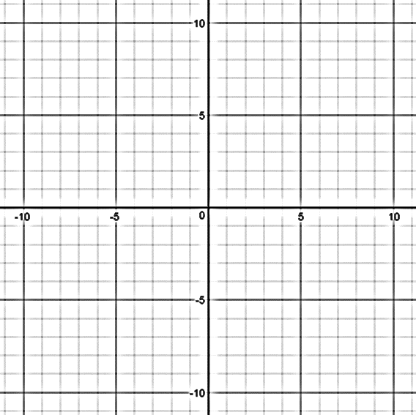  Graph:
Recursive Equation:

Table:

n | 0 | 1 | 2 | 3 | 4 | 5 | 11 | 17 | 21
t(n)

- Is it possible for the equation representing $t(n)$ to equal 400? Justify your answer.

- Create the same multiple representations as you did in part (a) for the function $f(x) = 4x - 9$.
Equation:  $$f(x) = 4x - 9$$ | Graph:
Table:

n | 0 | 1 | 2 | 3 | 4 | 5 | 11 | 17 | 21
t(n)

- How are $f(x)$and $t(n)$ different? How can you see their differences in each of the representations?
Equation: | Graph: | Table:

- For the function $f(x) = 4x - 9$, is it possible for $f(x)$ to equal 400? Explain why or why not.

5-112. Let us consider the difference between $t(n) = 2 · 3^{n}$ and $f(x) = 2 · 3^{x}$ .
- Is $f(x) = 2 · 3^{x}$ a function? Why or why not? Is $(n) = 2 · 3^{n}$ a function?

- Is it possible for $t(n)$ to equal 1400? If so, find the value of $n$ that makes $t(n) = 1400$. If not, justify why not.

- Is it possible for $f(x$) to equal 1400? If so, find the value of $x$ that makes $f(x) = 1400$.

- How are the two functions similar? How are they different?

5-113. LEARNING LOG “Sequences vs. Functions”
Is a sequence a function? Justify your answer completely. If so, what makes it different from the functions that are usually written in the form f(x) = ________? If not, why not?

Learning Target #2: “I can identify sequences as either arithmetic or geometric.” Learning Target #5: “I can write arithmetic and geometric sequences both explicitly and recursively.” F-BF-2
a.) | n | 0 | 1 | 2 | 3 | 4 | 5 |  | b.) | n | 0 | 1 | 2 | 3 | 4 | 5
 | t(n) |  | 36 | 63 | 90 | 117 |  |  |  | t(n) |  | 12 | 72 | 432 | 2592
Here are two tables:

- Determine if the tables represent geometric or arithmetic sequences or neither. Explain.

- Determine the zeroth term and the fifth term for both tables.

- Write the explicit and recursive equations for both tables.
Table a.) | Table b.)
Explicit Equation: | Explicit Equation:
Recursive Equation: | Recursive Equation:

