Sequences Review Worksheet
- For the given sequences: 2, 4…
  - If the sequence is arithmetic,
write an explicit equation. | write a recursive equation.

  - If the sequence is geometric,
write an explicit equation. | write a recursive equation.

- What TWO things do you need when writing a recursive equation?

- 5-91. Thanks to the millions of teens around the world seeking to be just like their math teachers , industry analysts predict that sales of the new πPhone will skyrocket!
  - If you were to write the number of πPhones the store received each week as a sequence, would your sequence be arithmetic, geometric, or something else? Justify your answer.

  - The article provides a model for how many πPhones the store expects to sell. They start by selling 100 πPhone pre-orders in week zero. Write an explicit equation that starts with “$t(n) =$” to find the number of πPhones sold during the nth week without finding all of the weeks in between.

  - Using the explicit equation from b., predict the number sold in the 4th week.

  - The store needs to know how many phones to order for the last week of the year. If you knew the number of πPhones sold in week 51 how could you find the sales for week 52? Write a recursive equation to show the predicted sales of πPhones in the nth week. (remember to the 2 thing you need for a recursive equation)

  - How many πPhones will the store predict it sells in the 52nd week? (use the explicit equation)

- Ellie contributes to the housework and gets a weekly allowance of $10. She just started helping out, but she has $50 from your birthday.
  - Write an explicit equation for this situation.

  - Using the explicit equation, how much money would she have in 9 weeks?

  - Write a recursive equation for this situation.

  - In 10 weeks, she will have $150. Using the recursive equation, determine how much money Ellie will have in week 11.

- Create your own arithmetic sequence. Create the equation, the table and the graph for your sequence.
Equation: | 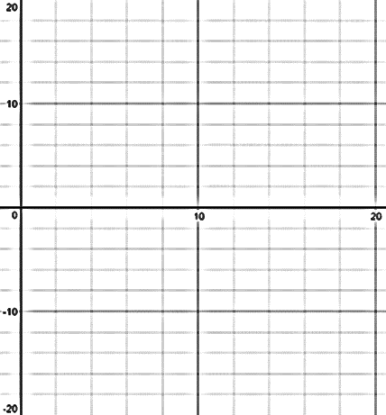  Graph:
Table:

n | 0 | 1 | 2 | 3 | 4 | 5 | 10 | 25 | 100
t(n)

- Create your own geometric sequence. Create the equation, the table and the graph for your sequence.
Equation: | Graph:
Table:

n | 0 | 1 | 2 | 3 | 4 | 5 | 10 | 25 | 100
t(n)

- Is the sequence 8, 8, 8, 8… arithmetic or geometric? Why?

