REVIEW PAGE 1…………… PUT THIS ON PAGE 30 OF YOUR INTERACTIVE NOTEBOOK!

- Determine if the given graphs are functions or relations. Then determine the domain and range.
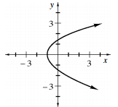
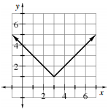
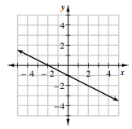
0

- Write the equation of a line that travels through the 2 given points.

  - $(-3 , -2)$ and $(4, 1)$

  - $(-5 , 3)$ and $(1, 3)$

  - $(1 , -1)$ and $(2, -4)$

  - $(-3 , 1)$ and $(3, 3)$

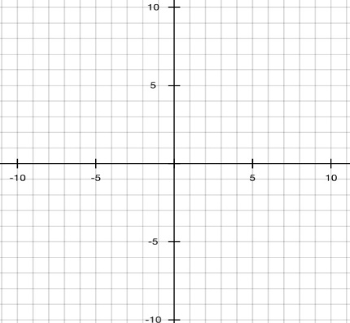
- Graph these equations on the given coordinate plane.

  - $y=-\frac{2}{3}x+5$
  - $y=5x-9$
  - $y=\frac{3}{5}x-7$

- Use the function machines, to evaluate for the given input or output.

a. | b. | c.
d. | e. | f.
g. | g. | i.

