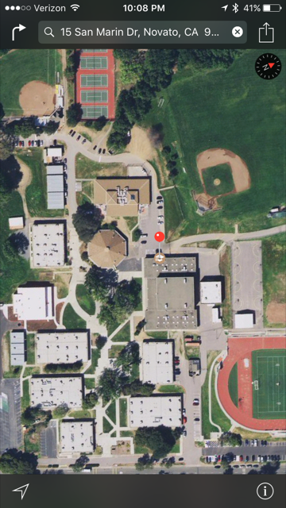
 |  |  |  |  |  | World Language Building
 |  |  |  |  |  | 806 Kats
 |  |  |  |  |  | 802 Lemuix
 |  |  |  |  |  |  |  |  |  |  |  |  |  |  |  |  |  |  |  | Student Center
 |  |  |  |  |  |  |  |  |  |  |  |  |  |  |  |  |  |  |  |  |  |  |  |  |  |  |  |  |  |  |  |  |  |  |  | Mini Gym
 |  |  |  |  |  |  |  | Cafeteria |  |  |  |  |  |  |  |  |  |  |  |  |  |  |  |  |  | Gym
 |  |  |  |  |  |  |  |  |  |  |  |  |  |  |  |  |  |  |  |  |  |  |  |  |  |  |  |  |  |  |  |  |  |  |  |  |  | Snack Shack
 |  |  |  |  |  |  |  |  |  | Library
 |  |  |  |  |  |  |  |  |  |  |  |  |  |  |  |  |  |  |  |  |  | 501 Davis
 |  |  |  |  |  |  |  |  |  |  |  |  |  |  |  |  |  |  |  |  |  |  |  |  |  | 505 Laabs
 |  | 206 Williams |  |  |  |  |  |  |  |  |  |  |  |  |  |  |  |  |  |  |  |  |  | 407 Watson
 |  |  |  |  |  |  |  | 204 Vogl
 |  |  |  |  |  |  | Front Office
 |  |  |  |  |  |  |  |  |  |  |  |  |  |  |  |  |  |  |  |  |  |  | Front Sign

Team 1

$y≥2x-5$ $y<-2$
Team 2
$y<\frac{1}{3}x+5$ $y≥\frac{1}{2}x+1$
Team 3
$y≥-5x+14$ $y≥\frac{2}{3}x+12$
Team 4
$y≤-x-4$ $y≤\frac{2}{5}x+7$ $y>\frac{1}{5}x+2$
Team 5
$y>12$ $y≤13$
Team 6
$y<\frac{3}{7}x$ $y≥-\frac{4}{3}x+3$
Team 7
$x>-5$ $x≤-1$
Team 8
$y≥x+16$ $y<-\frac{2}{7}x+15$

