Name: _____________________________Per: ___ Formative Scores: #1:_____ #2:_____ #3:_____ #4:_____ #5: _____
Inequalities Learning Targets CheckPoint
Learning Target #1: “I understand all of the symbols associated with inequalities and understand what a solution set represents.”
- 9-108. Determine if the following statements are true or false. Homework Help ✎

___________ ___________ ___________ ___________

- Explain when to use an open boundary point.

- Explain when to use a closed boundary point.

- Explain when to use a dashed boundary line.

- Explain when to use a solid boundary line.

- What does the solution set represent?

Learning Target #2: “I can create, solve, and graph inequalities in one variable.” A-CED.1, A-REI.3
- 9-107. Write the inequality that represents the $x$-values highlighted on each number line below. Homework Help ✎

_______________________ _______________________ _______________________

- Is 7a, is 6 included in the solution set? Why or why not?

- In 7b, is 1 included in the solution set? Why or why not?

- 9-116. Solve the following inequalities for the given variable and represent the solutions on a number line. 9-116 HW eTool (CPM). Homework Help ✎

- A plumber is going to fix a leak at a house. In order for the job to be worth his time it needs to cost at least $350. For him to inspect the property, it will cost the home owners $10. Then his hourly rate is $68. At least how many hours would he need to work to make the job worth his time.

Learning Target #3: “I can create, solve, and graph inequalities in two variables.” A-REI.12
- Explain how you know whether to shade above or below the boundary line.

- Graph the following inequalities and shade the solution set.

$y≤-\frac{3}{4}x+2$ $y>3x-7$
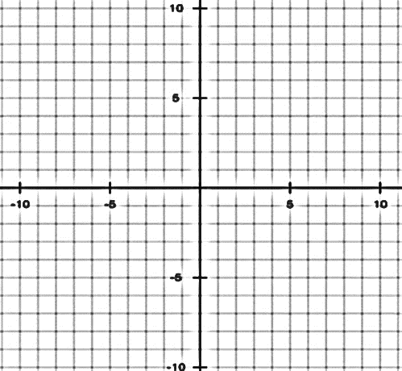

- Mr. Davis wants to score at least 6.5 points in a major chess tournament. He scores 1 point for each game that he wins and he scores 0.5 points for each game that ends in a tie. Write an inequality that represents the number of games Mr. Davis should win ($x$) and the tie ($y$) to achieve his goal. Graph the solution set.

Learning Target #4: “I can graph the solution set to a system of linear inequalities in two variables.” A-REI.12
- What is the solution set to a system of linear inequalities?

- 9-106. Graph and shade the solution for the system of inequalities below. Homework Help ✎
$$y ≥ \frac{3}{4}x - 2$$
$$y < -\frac{1}{2}x + 3$$

- 9-110. For the Spring Festival, the Math Club is selling rulers for $1 and compasses for $2.50. 9-110 HW eTool (Desmos). Homework Help ✎

- While the club would like to sell as many items as they can to raise funds, they need to make at least $15.00 to break even. Write an inequality to represent this situation. Let $r$ = the number of rulers sold and $c$ = the number of compasses sold.

- School rules state that the club can sell a maximum of 25 items for the festival. Write an inequality for this constraint (limitation).

- Graph the inequalities from parts (a) and (b) on the same set of axes so that compasses are represented on the $x$-axis and rulers are represented on the $y$-axis. Find the region of points that are solutions to each of them. Can this region fall below the$x$-axis or to the left of the $y$-axis? Why or why not?

- What do the points in the solution region represent?

Learning Target #5: “I can interpret solutions as viable (practical, realistic, usable) or nonviable (not practical, realistic, usable) within context.” A-CED.3
- What does viable mean?

- What does non-viable mean?

- Explain what a viable solution is.

- Explain what a non-viable solution is.

- Look at problem #8. Choose a viable solution and explain what it means in context.

- Look at problem #8. Choose a non-viable solution and explain what it means in context.

- Look at problem #10. Choose a viable solution and explain what it means in context.

- Look at problem #10. Choose a non-viable solution and explain what it means in context.

- Look at problem #12. Choose a viable solution and explain what it means in context.

- Look at problem #12. Choose a non-viable solution and explain what it means in context.

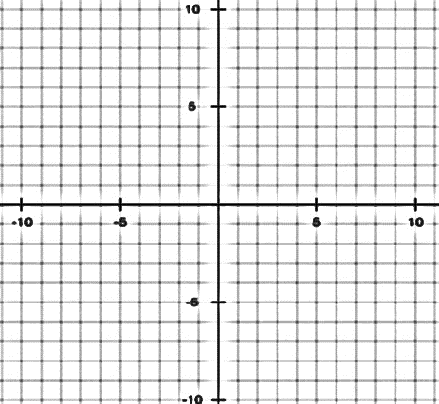
*** EXTRA CREDIT: Create an inequality context problem that would include 2 variables (x and y). Next, create the inequality and graph the solution set. Lastly, choose two solutions, one viable and one non-viable, and explain what the solution point represents.

