Name: ___________________________________________ Period: __________ Formative Score: ______________
HW #4 Mandatory Problems:
Learning Target #2: “I can create, solve, and graph inequalities in one variable.” A-CED.1, A-REI.3
- 9-85. Write and solve an inequality for this situation: To honor 50 years in business, All Strikes Bowling is having an anniversary special. Shoes rent for $1.25 and each game is $0.75. If Charlie has $20 and needs to rent shoes, how many games can he bowl? Then graph the solution set on the number line below.

- $3x-\left(x+2\right)≥0$
- $-x+6>x+2$

Learning Target #3: “I can create, solve, and graph inequalities in two variables.” A-REI.12
- Write the inequality that is represented by the given graphs in the box provided.
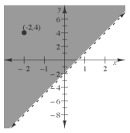
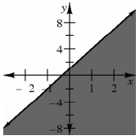

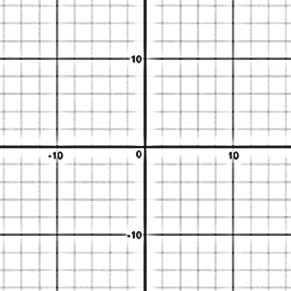
- Create a context that could be modeled by an inequality. Write the inequality and graph it. Choose a solution within the solution set and explain what it means.

Learning Target #5: “I can interpret solutions as viable (practical, realistic, usable) or nonviable (not practical, realistic, usable) within context.” A-CED.3
- Camille is selling bracelets and earrings to make money for her summer vacation plans. The bracelets cost $2 and the earrings cost $3. She needs to make at least $500 to afford her summer plans. Create and graph the inequality that this situation represents. Choose 3 points within the solution set and explain what each point is representing and if it is a viable solution.
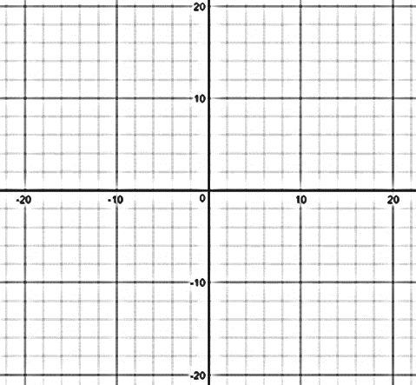

Individual Practice Problems: Look at the Learning Target Page and pick 3 practice problems from the chart.
Learning Target | Problem | Work

