Name: ___________________________________________ Period: __________ Formative Score: ______________
HW #3 Mandatory Problems:
Learning Target #1: “I understand all of the symbols associated with inequalities and understand what a solution set represents.”
- Write the algebraic expression for: 6 less than a number is greater than 4. _____________________________________

- 9-74. Thui made the following hypotheses: $2n - 1 < 5$ and $n + 1 ≤ 2n$. Which of the following conclusions can she make? Homework Help ✎

  - WORK:

  - $n ≥ 1 and n < 3$

  - $n > 1 and n ≤ 3$

Learning Target #2: “I can create, solve, and graph inequalities in one variable.” A-CED.1, A-REI.3
- Mrs. Davis has $20 to spend on an Uber ride. The ride cost $5 to pick up and then $2.50 per mile. Write and solve an inequality to determine the maximum number of miles Mrs. Davis can ride in the Uber. Then graph the solution set.

Learning Target #3: “I can create, solve, and graph inequalities in two variables.” A-REI.12
- Explain when you graph with a solid boundary line.

- Explain when you graph with a dashed boundary line.

- Mrs. Davis was awarded $200 to spend in her classroom. She wants to buy whiteboard markers and batteries for the calculators. The packs of whiteboards markers cost $10 and the packs of batteries cost $5. Write an inequality to represent this situation. Graph the inequality. Then list three possible buying options I have and explain what it means.
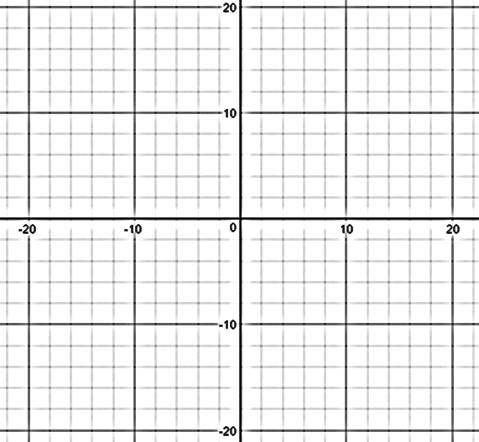

Absolute Value Equations Ch 3
- Solve the following absolute value equation. How many solutions should you have? Check your work!
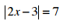

Systems of Equations Ch 4
- Solve the linear systems. Check your solution. What is your solution? How should you write your solution?
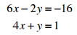
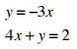

Individual Practice Problems: Look at the Learning Target Page and pick 3 practice problems from the chart.
Learning Target | Problem | Work

