Name: ____________________________ Formative Scores: #1: _____ #2:_____ #3:_____ #4:_____ #5:_____ #6:_____
HW #8
Simplify the exponential expressions.
- $\left(s^{4}tu^{2}\right)\left(s^{7}t^{-1}\right)$ | - ${64}^{1/2}$ | - ${10}^{4/3}$ | - $\left(x^{2}y^{3}\right)\left(x^{-2}y^{-2}\right)$
- ${64}^{2/3}$ | - $\frac{14a^{3}b^{2}}{21a^{4}b}$ | - $\frac{4x^{18}}{{\left(2x^{22}\right)}^{0}}$ | - ${81}^{7/4}$
- $2m^{3}n^{2}∙3{mn}^{4}$ | - ${25}^{5/2}$ | - $\frac{x^{3}y^{4}}{x^{2}y^{3}}$ | - ${\left(3w^{-2}\right)}^{4}$

- Complete the diamond problems.

- Solve the absolute value equation.
$$\left|2x-3\right|=23$$

- Write the equation of the line that passes through the points $\left(-4, -11\right) and \left(-3, -9\right).$

- Multiply using a generic rectangle. Then write the area as a product of the dimensions equal to the sum of the parts.
$$\left(2x+1\right)\left(3x+4\right)$$

- Graph the system of inequalities. Make sure to shade the correct solution region.
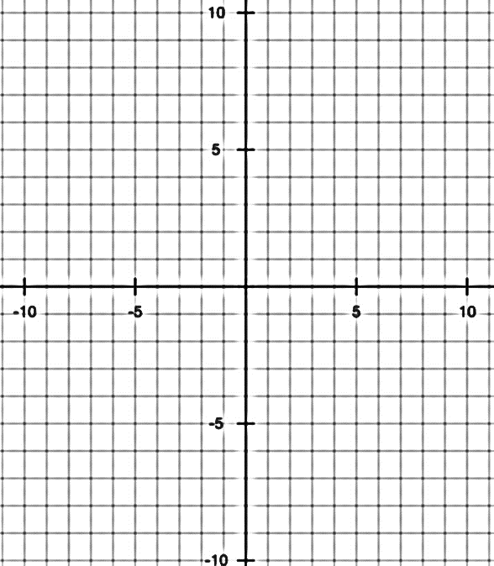
$$2x+3y <12$$
$$3x+2y >12$$

DELIBERATE PRACTICE
LT and Prob # | Work

