Name:__________________________________ Per:____ Scores: #1:_____ #2:_____ #3:_____ #4:_____ #5:______
HW #16
Learning Target #1: “I can recognize that sequences are functions with limited domain.” F-IF-3
What is the difference between a sequence $t(n)$ and the function $f(x)$ with the same equation?

Tell me EVERYTHING you know about sequences.

Learning Target #2: “I can identify sequences as either arithmetic or geometric.”
CL 5-124. Determine if the following sequences are arithmetic, geometric, or neither. Justify your answer.
- −7, −3, 1, 5, 9, ... | - −64, −16, −4, −1, ... | - 1, 0, 1, 4, 9, ... | - 0, 2, 4, ... | - -9, -9, -9, -9,…

Learning Target #3: “I can construct arithmetic sequences in the four representations: situation, table, graph, and equation, and use them to model situations.” F-LE-2, F-BF-2
Here is an explicit equation for an arithmetic sequence: $t\left(n\right)=2n-5$
- Create the list of terms.

- Create a situation that would be represented by this equation.

- Create a table.

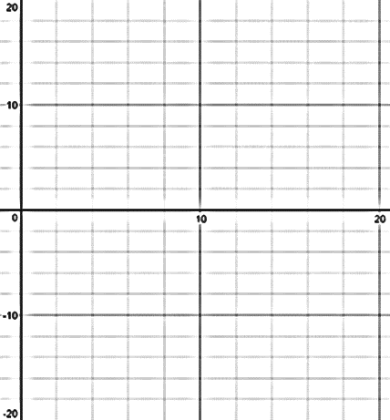
- Create a graph

Learning Target #4: “I can construct geometric sequences in the four representations: situation, table, graph, and equation, and use them to model situations.” F-LE-2, F-BF-2
5-92. A new πRoid, a rival to the πPhone, is about to be introduced. It is cheaper than the πPhone, so more are expected to sell. The manufacturer plans to make and then sell 10,000 pre-orders in week zero and expects sales to increase by 7% each week.
- Write an explicit and a recursive equation for the number of πRoids sold during the nth week.
explicit equation:

recursive equation:

- What if the expected weekly sales increase were 17% instead of 7%? Now what would the new explicit equation be? How would it change the recursive equation?
explicit equation:

recursive equation:

Learning Target #5: “I can write arithmetic and geometric sequences both explicitly and recursively.” F-BF-2
- Explain the difference between an explicit equation and a recursive equation.

- Write both an explicit equation and a recursive equation for the sequence: –4, 3, 10, 17, 24, …

- Write both an explicit equation and a recursive equation for the sequence: 5, –5, 5, –5, 5, …

