Name: ___________________________________________ Period: __________ Formative Score: ______________
HW #2 Mandatory Problems:
Learning Target #1: “I understand all of the symbols associated with inequalities and understand what a solution set represents.”
- Write the algebraic expression for: the greatest possible value of $3y$ is $30$. _____________________________________

- Write the algebraic expression for: the minimum value of $2x + 1$is $13$. _______________________________________
Learning Target #2: “I can create, solve, and graph inequalities in one variable.” A-CED.1, A-REI.3
- Mrs. Davis decided that she would spend no more than $120 to buy a jacket and a skirt. If the price of the jacket was $20 more than 3 times the price of the skirt, find the highest possible price of the skirt. Then graph the solution set on the number line.

Learning Target #3: “I can create, solve, and graph inequalities in two variables.” A-REI.12
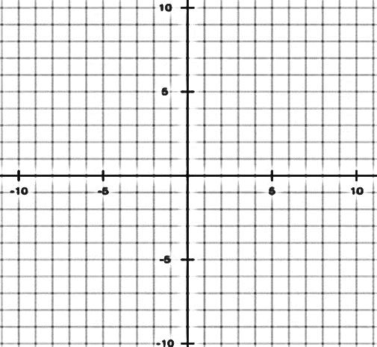
- 9-84. Graph the inequalities below on graph paper. Homework Help ✎

  - $y ≤ - x + 5$

  - $y > \frac{2}{3}x- 1$

Linear Equations Ch 2:
9-73. Line m has intercepts (−7, 0) and (0, −2). Homework Help ✎ Find the equation of line m. Then determine if the point (49, −16) also on line m? How do you know?

Functions Ch 1:
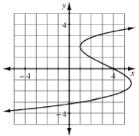
1-71. Examine the graph of the relationship below.
Use it to estimate:
$y$when $x = –4$ ________________________________________________
$y$when $x = 1$ ________________________________________________
$y$when $x = 4$ ________________________________________________
Is this relationship a function? Why or why not?

Individual Practice Problems: Look at the Learning Target Page and pick 5 practice problems from the chart.
Learning Target | Problem | Work

