Name: ____________________________ Formative Scores: #1: _____ #2:_____ #3:_____ #4:_____ #5:_____ #6:_____
HW #9
Learning Target #1: “I can apply the rules of exponents.” N-RN.1, N-RN.2
5-9. Benjamin is taking Algebra 1 and is stuck on the problem shown below. Examine his work so far and help him by showing and explaining the remaining steps. Homework Help ✎
Original problem: Simplify (3a⁻²b)³.
He knows that (3a⁻²b)³ = (3a⁻²b)(3a⁻²b)(3a⁻²b). Now what?

5-10. Simplify each expression below. Assume that the denominator in part (b) is not equal to zero. Homework Help ✎
a.) (x³)(x⁻²) b.) $\frac{y^{5}}{y^{-2}}$ c.) 4⁻¹ d.) (4x²)³ e.) ${\left(a^{-2}bc^{3}\right)}^{0}$

Learning Target #3: “I can investigate the family of exponential functions through the four different representations, graph, table, equation, and situation, and I can interpret the key features/parameters.” F-IF.4, F-IF.7e, F-LE.2, F-LE.5
7-14. Sketch the shape of the graph of the function y = b^{x} given each of the following values of b.

a.) b is a number larger than 1.
b.) b is a number between 0 and 1.
c.) b is equal to 1.

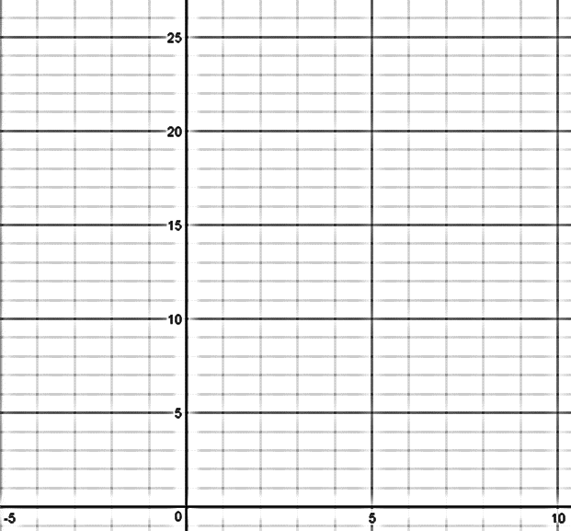
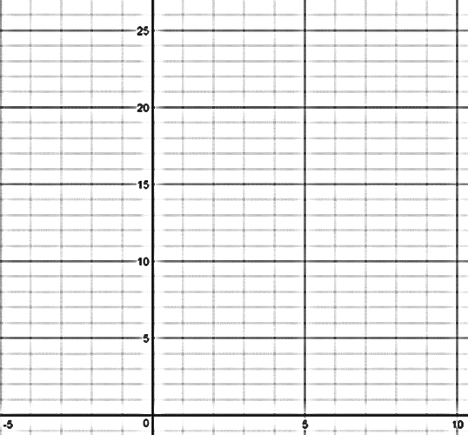
$b=$ $b=$ $b=$

7-25. Brianna is working on her homework. Her assignment is to come up with four representations for an exponential function of her choosing. She decides it is easiest to start by writing an equation, so she chooses $y={1200\left(\frac{1}{2}\right)}^{x}$ . Help Brianna create the other three components of the web. Homework Help ✎

Table:
Graph:

Situation:

Learning Target #2: “I can create and graph exponential functions and use them to solve problems.” A-CED.1, A-CED.2, N-Q.2,N-Q.3, F.BF.1
7-18. In 1999, Charlie received the family heirloom marble collection consisting of 1239 marbles. Charlie’s great-grandfather had started the original marble collection in 1905. Each year, Charlie’s great-grandfather had added the same number of marbles to his collection. When he passed them on to his son, he insisted that each future generation add the same number of marbles per year to the collection. When Charlie’s father received the collection in 1966, there were 810 marbles. Homework Help ✎ Create a table, graph, and equation to represent this situation.

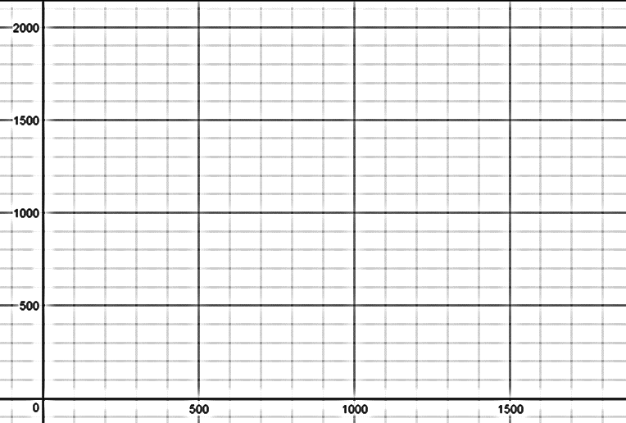
Table: Graph:

Equation:

