Name: ____________________________ Formative Scores: #1: _____ #2:_____ #3:_____ #4:_____ #5:_____ #6:_____
HW #10
Learning Target #1: “I can apply the rules of exponents.” N-RN.1, N-RN.2
7-100.) Rewrite the following exponential expressions, then calculate the value. Homework Help ✎

- 64^{2/3}
- 25^{5/2}
- 81^{7/4}

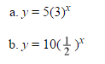
Learning Target #2: “I can create and graph exponential functions and use them to solve problems.” A-CED.1, A-CED.2, N-Q.2,N-Q.3, F.BF.1
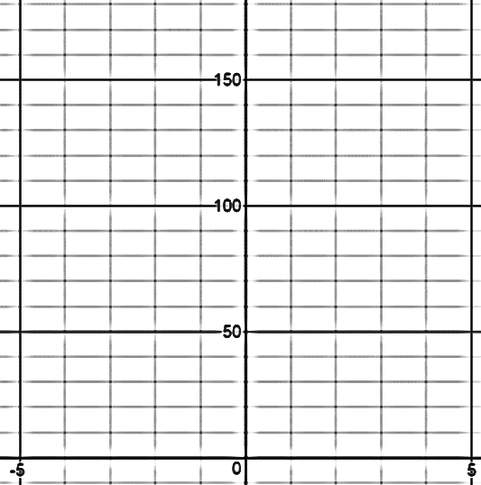

Learning Target #3: “I can investigate the family of exponential functions through the four different representations, graph, table, equation, and situation, and I can interpret the key features/parameters.” F-IF.4, F-IF.7e, F-LE.2, F-LE.5
7-62. Use the clues in the graph at right to find a possible corresponding equation in y = ab^{x} form. Homework Help ✎
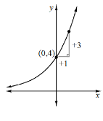
7-87. Find the exponential function in y = a · b^{x} form that represents the situation described below. Homework Help ✎
- Passes through the points (0, 4) and (2, 1).

Learning Target #4: “I can identify exponential functions as representing growth or decay.” I-IF.8b, F-LE.1c, F-IF.6
7-16. Identify the situation as growth or decay. Then, write the multiplier for each increase or decrease described below. Homework Help ✎
- A 25% increase: Growth or Decay? Multiplier: _________________
- A decrease of 18%: Growth or Decay? Multiplier: _________________
- An increase of 39%: Growth or Decay? Multiplier: _________________
- A 94% decrease: Growth or Decay? Multiplier: _________________
- Identify each example as growth or decay:
LT #2 a | LT #2 b | LT #3 7-62
LT #3 7-87 | LT #4 CL 7-117

CL 7-117. A share of ABC stock was worth $60 in 2005 and only worth $45 in 2010.
- Find the multiplier (round to the nearest thousandth – 3 decimal places) and the percent decrease.

- Write an exponential function that models the value of the stock starting from 2005.

- Assuming that the decline in value continues at the same rate, use your answer to (b) to predict the value in 2020.

Learning Target #6: “I can interpret solutions as viable (makes sense in context) or nonviable (doesn’t make sense in context) within context.” A-CED.3
- In the context of the problem above (ABC stocks) what would a negative exponent represent? Is it viable to have a negative exponent?

- Using the exponential equation from CL 7-177 b, Mr. Davis’ grandparents decided that instead of giving him graduation money, they would invest in the ABC stocks in his name. How much was a share of the ABC stocks worth when he graduated in 2001? Based on all of the information, was this a good investment?

