Name: ___________________________________________ Period: __________ Formative Score: ______________
HW #1 Mandatory Problems:
9-51. Solve each of the following inequalities for the given variable. Represent your solutions on a number line. 9-51 HW eTool (CPM). Homework Help ✎

- 2(3p + 1) > −4
- 9k − 2 < 3k + 10
- 5 − h > 4

9-53. Identify the statements below as sometimes true, always true, or never true. Homework Help ✎

- −4 < 9

- x < 1
- − 5 > −2

- 3x + 5 = 2
- 61 = 61

- −6 < −6

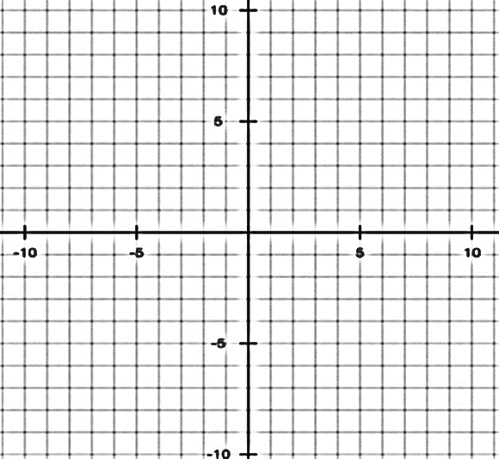
- Graph this linear system.
$$x-3=y$$
$$2x-6-y=7$$

- Write the linear equation of a line passes through the points $\left(2, 3\right)$ and $\left(6, -5\right)$.

