Geometric Sequences
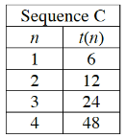
- Is this given sequence arithmetic, geometric, or neither? Explain how you know.

- What does $t(1)=$? $t(0)=$?

- When the growth pattern MULTIPLIES a number to each term, the value that is multiplied is known as the COMMON RATIO. What is the common ratio for this sequence?

- Graph the sequence. Should the sequence be discrete or continuous? EXPLAIN why you choose your answer.
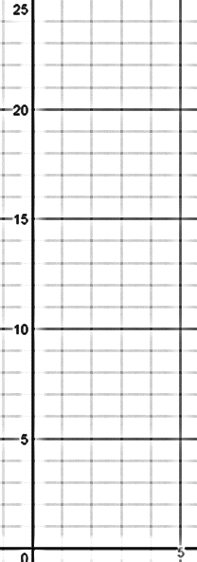
- A Geometric Sequences models what type of function?

- What equation do you use when writing equations of that type of function? What does $a$ stand for? What does $b$ stand for?

- Now, use that model from 6. to write the equation for this type of sequence. Your equation should start with $t(n)$, not $y$, because it is a sequence equation, not a function equation.

- What is the domain (input, independent variable) for the sequence equation that you have written?

- How is the common ratio related to the graph and the equation? Why does this make sense?

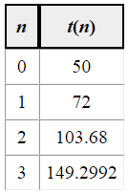
5-96. Write an explicit equation for each table below. Check that your equations work for all of the entries in the table.
