Name: _________________________________________________ Per: __________ Score:_________

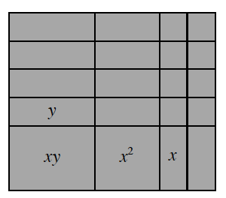**Generic Rectangles and Diamond Problems Review**

**8-1.** Review what you know about products and sums below.

1. Write the area of the rectangle at right as a product and as a sum.  Remember that the product represents the area found by multiplying the length by the width, while the sum is the result of adding the areas inside the rectangle.
2. Use a generic rectangle to multiply (6*x* − 1)(3*x* + 2). Write your solution as a sum.

**8-3.**Find the sum and the product for the following generic rectangles.  Are there any special strategies you discovered that can help you determine the dimensions of the rectangle?

|  |  |  |
| --- | --- | --- |
| https://ebooks.cpm.org/images/cca/ch8/cca.8-3a.png | https://ebooks.cpm.org/images/cca/ch8/cca.8-3b.png | https://ebooks.cpm.org/images/cca/ch8/cca.8-3c.png |

**8-10.** In a previous course you used the Distributive Property and common factors to change expressions written as sums into expressions written as products.  For example:

Since 6 is the greatest common factor of both terms, 12*x* + 18 may be rewritten: 12*x* + 18 = 6(2*x* + 3).

Here *x*is a common factor of every term, so  *x*2 + *xy + x* may be rewritten:

*x*2 +*xy* + *x*= *x*(*x* +*y*+ 1).

Use the greatest common factor to rewrite each sum as a product.

1. 4*x +*8
2. 10*x* + 25*y* + 5
3. 2*x2 −*8*x*
4. 9*x2y +*12*x +*3*xy*

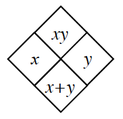**8-9.** Remember that a Diamond Problem is a pattern for which the **product** of two numbers is placed on top, while the **sum** of the same two numbers is placed on bottom. (This pattern is demonstrated in the diamond below.) Complete each Diamond Problem below.

 