3-1) Expand the exponential expressions.

a. $y^{7}$=

b. ${5\left(2m\right)}^{3}$=
c. ${\left(x^{3}\right)}^{2}$=

d. ${4x}^{5}y^{2}$=

3-2) Simplify the exponential expressions.

i. $\frac{x∙x∙x}{x}$=
ii. $\frac{x^{5}}{x^{2}}=$
iii. $x^{2}{∙x}^{3}=$ =
iv. $k^{3}∙k^{5}=$
v. $\frac{16k^{3}}{8k^{2}}$=
vi. m⁶ · m=
vii. $x^{4}∙x^{5}∙x^{3}=$
viii. $\frac{6x^{3}y}{2y}$=
Challenge: $\frac{5x^{50}}{10x^{15}}$=

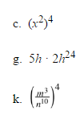
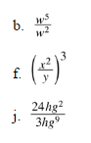
3-3) Simplify each exponential expression.
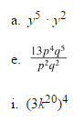

3-4) Write 3 exponential expressions that will simplify to $x^{12}.$
Multiplication:
Division:
Power of a Power (Grouping):

3-5) What is the difference between $x+x$ and $x∙x$?

