Name: _______________________________ Period: _________ Team Number: __________
Teammates: ___________________________________________________________________

Unit #3 PBL “Cell Phone Grant” Entry Activity
“Can you hear me now?”
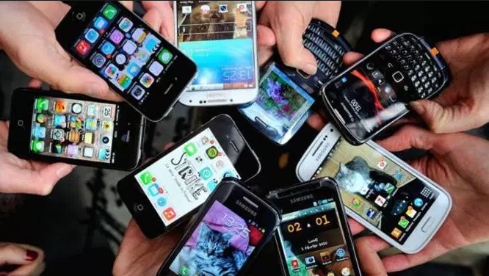
1. Observations from Old Cell Phone Commercials:
______________________________________________________________________________________________________________________________________________________________________________________________________________________________________________________________________________________________________________________________________________________________________________________________________________________________________________________________________________________________________________________________

2. Brainstorm Your Ideal Phone:
______________________________________________________________________________________________________________________________________________________________________________________________________________________________________________________________________________________________________________________________________________________________________________________________________________________________________________________________________________________________________________________________

3. From your brainstorm and class discussion, what aspects would make a phone ideal for educational purposes?
______________________________________________________________________________________________________________________________________________________________________________________________________________________________________________________________________________________________________________________________________________________________________________________________________________________________________________________________________________________________________________________________

