- Inequality Symbols are used _______________________________________________________________________

$$< > ≤ ≥$$
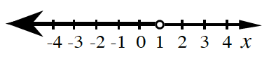
9-46.) Write an inequality that represents the solutions on each number line below.

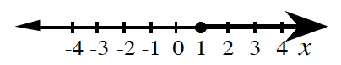

b.

- When graphing in inequality on a number line,

9-47.) Solving a linear inequality:
$$2x-5≥3$$

- Boundary Point:

9-48) THE PROCESS FOR SOLVING A LINEAR INEQUALITY WITH ONE VARIABLE:
1.

2.

3.

4.

