9-44) Reflection of the Human Number Line

9-45) Based on observations from the Human Number Line:
a.) Compare the solutions to an inequality (like $x≥2$) with that of an equation ( like $x=3$). What is different? What causes this to happen?

b.) How many solutions does an inequality such as $x≥1$ have?

c.) How is the result of $- 1 ≤ x ≤ 4$ different from the other inequalities? What about the result of $x^{2} >4$?

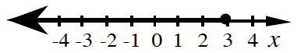
9-46) Write an inequality that represents the solution set on each number line. Highlight the number lines, as I have.
c.)

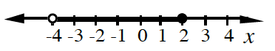
d.)

9-47) Solving a linear inequality
a.) How many solutions are there?

b.) What is the smallest solution for x? This point is called a boundary point.

c.) What is the significance of the boundary point? What is its relationship with the inequality 2x − 5 > 3?

d.) Write an inequality that represents the solutions for x. On a number line, highlight the solutions for x. Be ready to share your number line with the class.

9-48) Your Turn: Solve this linear inequality:
$$3x+1<7$$

