There are several ways to write the number 12 as a product of factors. For example, 12 can be rewritten as 3 · 4, as 2 · 6, as 1 · 12, or as 2 · 2 · 3. While each of these products is accurate, only 2 · 2 · 3 is considered to be factored completely, since the factors are prime and cannot be factored themselves. During this lesson you will learn more about what it means for a quadratic expression to be factored completely.
8-35. Review what you have learned by factoring the following expressions, if possible. Use the Generic Rectangle/Diamond Problem process.

- $9x^{2}-12x+4$
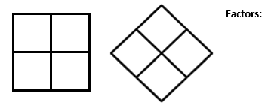

- $81m^{2}-1$

- $28+x^{2}-11x$

- ${3n}^{2}+9n+6$

- An expression is considered completely factored if none of the factors can be factored any more. Often it is easiest to remove common factors first, before factoring with a generic rectangle.
  - Rewrite this expression 10x² + 25x − 15 with the common factor factored out. Then factor completely.

8-38. Factor each of the following expressions as completely as possible.
3x³− 6x² − 45x | 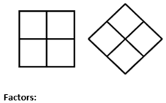  12t² − 10t + 2 | 5x² + 15x − 20

