8-24. Factor each quadratic expression below, if possible. Use the Generic Rectangle/Diamond Problem process.
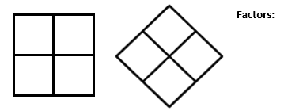

- $x^{2}+6x+9$

- $2x^{2}+5x+3$
- $x^{2}+5x-7$

- ${3m}^{2}+m-14$

8-25. Most quadratic expressions are written in the form ax² + bx + c. But what if a term is missing? Or what if the terms are in a different order? Consider these questions while you factor the expressions below. Share your ideas with your teammates and be prepared to demonstrate your process for the class.

- $9x^{2}-4$

- $12x^{2}-16x$
- $3+8k^{2}-10k$

- $40-100m$

8-27. The multiplication table below has factors along the top row and left column. Their product is where the row and column intersect. With your team, complete the table with all of the factors and products.

Multiply | x − 2
x + 7
 | 3x² − 5x − 2 | 6x² + 5x + 1

