8-4. While working on problem 8-3, Casey noticed a pattern with the diagonals of each generic rectangle. However, just before she shared her pattern with the rest of her team, she was called out of class! The drawing on her paper looked like the diagram below. Can you figure out what the two diagonals have in common?
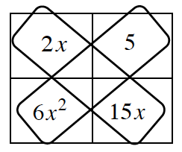

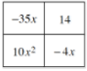
8-13. Examine the generic rectangle shown below.
Review what you learned in Lesson 8.1.1 by writing the area of the rectangle at right as a sum and as a product.

Does this generic rectangle fit Casey’s pattern for diagonals? Demonstrate that the product of each diagonal is equal.

8-14. FACTORING QUADRATIC EXPRESSIONS
To develop a method for factoring without algebra tiles, first model how to factor with algebra tiles, and then look for connections within a generic rectangle.
  - Using algebra tiles, factor 2x² + 5x + 3; that is, use the tiles to build a rectangle, and then write its area as a product.

  - To factor with tiles (like you did in part (a)), you need to determine how the tiles need to be arranged to form a rectangle. Using a generic rectangle to factor requires a different process.
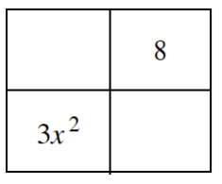
Miguel wants to use a generic rectangle to factor 3x² + 10x + 8. He knows that 3x² and 8 go into the rectangle in the locations shown at right. Finish the rectangle by deciding how to place the ten x-terms. Then write the area as a product.

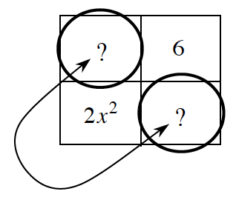
  - Kelly wants to find a shortcut to factor 2x² + 7x + 6. She knows that 2x² and 6 go into the rectangle in the locations shown at right. She also remembers Casey's pattern for diagonals. Without actually factoring yet, what do you know about the missing two parts of the generic rectangle?

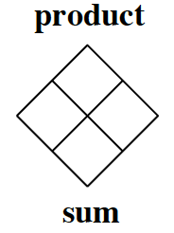
  - To complete Kelly's generic rectangle, you need two x-terms that have a sum of 7x and a product of 12x². Create and solve a Diamond Problem that represents this situation.

  - Use your results from the Diamond Problem to complete the generic rectangle for 2x²+ 7x + 6, and then write the area as a product of factors.

8-15. Factoring with a generic rectangle is especially convenient when algebra tiles are not available or when the number of necessary tiles becomes too large to manage. Using a Diamond Problem helps avoid guessing and checking, which can at times be challenging. Use the process from problem 8-14 to factor 6x² + 17x + 12. The questions below will guide your process.
  - Why would you use the generic rectangle/diamond problem process to factor?

  - When given a trinomial, such as 6x² + 17x + 12, what two parts of a generic rectangle can you quickly complete?

  - How can you set up a Diamond Problem to help factor a trinomial such as 6x² + 17x + 12? What goes on the top? What goes on the bottom?
  - Solve the Diamond Problem for 6x² + 17x + 12 and complete its generic rectangle.

  - Write the area of the rectangle as a product.

8-16. Use the process you developed in problem 8-14 to factor the following quadratics, if possible. If a quadratic cannot be factored, justify your conclusion.
  - x² + 9x + 18

  - 4x² + 17x − 15

  - 4x² − 8x + 3

  - 3x² + 5x – 3

  - 2x² − 9x – 5

