8-16. Use the process you developed in problem 8-14 to factor the following quadratics, if possible. If a quadratic cannot be factored, justify your conclusion.
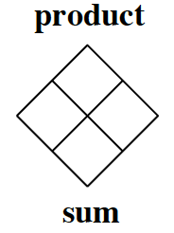
  - x² + 9x + 18

  - 4x² + 17x − 15

  - 4x² − 8x + 3

  - 3x² + 5x – 3

  - 2x² − 9x – 5

