Arithmetic Sequences (Lesson 5.2.2.)
5-56) Sequences have their own notation and vocabulary that help describe them, such as “term number” and “term value.” Consider the sequences below and answer the questions.
$$-9, -5, -1, 3, 7…$$
- Is this sequence arithmetic, geometric, or neither? EXPLAIN how you know.

- What is the first term of this sequence? In other words what is $t\left(1\right)=$?

- When the growth pattern ADDS a number to each term, the value that is added is known as the COMMON DIFFERENCE. It is the difference between each term and the term before it. What is the common difference for this sequence?

- Represent this sequence in the table representation. Remember, a sequence table compares the term number, $n$, to the term value,$t(n)$.

n |  | 1 | 2 | 3 | 4 | 5 | 6 | 7 | 8 | 9 | 10
t(n)

- What is the term value when the term number is zero? In other words, what is $t(n)$, when $n=0?$Add that value to your table.

- Graph the sequence. Should the sequence be discrete or continuous? EXPLAIN why you choose your answer.

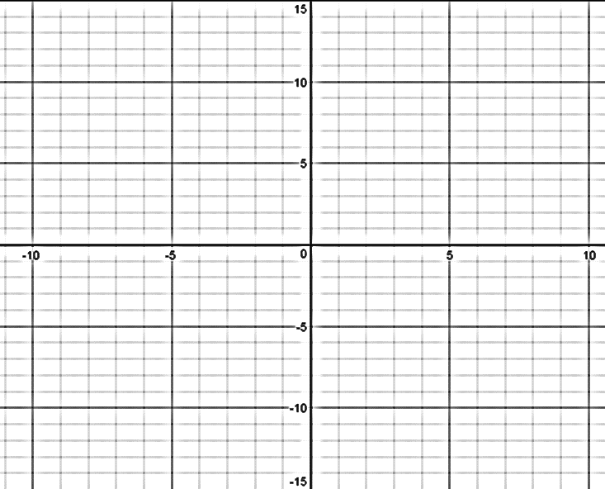

- Arithmetic Sequences model what type of function?

- What equation do you use when writing equations of that type of function? What does $m$ stand for? What does $b$ stand for?

- Now, use that model from h. to write the equation for this type of sequence. Your equation should start with $t(n)$, not $y$, because it is a sequence equation, not a function equation.

- What is the domain (input, independent variable) for the sequence equation that you have written?

- How is the common difference related to the graph and the equation? Why does this make sense?

5-57) Consider the sequence $-4, -1, 2, 5…$
- What is the term value for $t\left(0\right)$? What is the common difference?

- Create the multiple representations for this sequence.
Table: | Graph: | Equation:
n | t(n)
0
1
2
3
4
5
6
7
8
9
10

- Is it possible for the sequence ( $t(n)$ ) to equal 42? Why or why not? EXPLAIN your answer.

- Is it possible for the function ( $f(x)$ ) to equal 42? Why or why not? EXPLAIN your answer.

- Explain the difference between sequences and functions.

