Name: ____________________________________________ Team: _____________ Per: _____________
4-4) Environmental Club
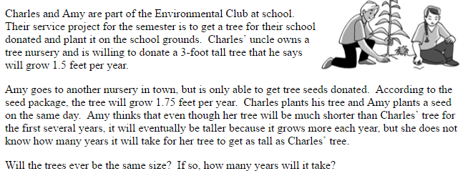
Let Statement:
Charles’ Tree’s Equation:
Let Statement:
Amy’s Tree’s Equation:

Time  (in years) | Charles’ Tree’s Height in Feet | Amy’s Tree’s Height in Feet |  | Use the equations to find out when the trees will be the same height and how tall they will be.

