PATTERN A
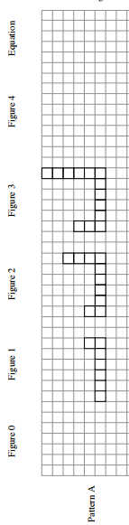

- What do you notice about the pattern? Write down observations.

- After everyone has had a moment on his or her own to examine the figures, discuss what you see with your team.

- Sketch the next figure in the sequence (Figure 4) for Pattern A above in the room provided. Figure 0 is the name of the figure that comes before Figure 1. Sketch Figure 0 above in the room provided.

- By how much is tile Pattern A growing? Where are the tiles being added with each new figure? Color in the new tiles in each figure with a marker or colored pencil on your resource page for each pattern.

- What would Figure 100 look like for Pattern A? Describe it in words. How many tiles would be in the 100th figure? Find as many ways as you can to justify your conclusion. Be prepared to report back to the class with your team’s findings and methods.

- Make a table for this tile pattern.
Figure #  $$x$$ | 0 | 1 | 2 | 3 | 4
# of Tiles
$$y$$

- Write an equation that relates the figure number, $x$, to the number of tiles, $y$.

PATTERN C
The growth of a tile Pattern C is represented by the equation $y = 3x + 1$.
- Fill in the table for Pattern C.
Figure #  $$x$$ | 0 | 1 | 2 | 3 | 4
# of Tiles
$$y$$

- Workspace:

- By how many tiles is Pattern C growing? What is the starting value?

- Where do you look in the table to see the growth and starting value?

- Where do you look in the equation to see the growth and starting value?

Name: __________________________________________________________ Period: __________ Score: __________
PATTERN B

- What do you notice about the pattern? Write down observations.

- After everyone has had a moment on his or her own to examine the figures, discuss what you see with your team.

- Sketch the next figure in the sequence (Figure 4) for Pattern A above in the room provided. Figure 0 is the name of the figure that comes before Figure 1. Sketch Figure 0 above in the room provided.

- By how much is tile Pattern A growing? Where are the tiles being added with each new figure? Color in the new tiles in each figure with a marker or colored pencil on your resource page for each pattern.

- What would Figure 100 look like for Pattern A? Describe it in words. How many tiles would be in the 100th figure? Find as many ways as you can to justify your conclusion. Be prepared to report back to the class with your team’s findings and methods.

- Make a table for this tile pattern.
Figure #  $$x$$ | 0 | 1 | 2 | 3 | 4
# of Tiles
$$y$$

- Write an equation that relates the figure number, $x$, to the number of tiles, $y$.

